Sign Language Translation Model

Kow Yong Chen
Product Manager / Data Scientist
B032410387

Celine Hew Boon Ling
ML Engineer
B032410385
Chong Kai Li
Data Engineer
B032410369
Terence Tay Zhe Zhi
MLOps
B032410388
Soong Jien Yong
ML Researcher
B032410365

Neoh Xin Yi
DevOps Engineer
B032410389

Executive Summary

Communication barriers between the Deaf community and the hearing majority remain a significant societal challenge. While recent advancements in Computer Vision have enabled automated Sign Language Recognition (SLR), many existing Deep Learning solutions suffer from high computational costs and a "Black Box" nature, making them difficult to audit for errors. Furthermore, the storage of raw video data raises significant privacy concerns.

This project proposes a lightweight, privacy-preserving SLR system capable of classifying 10 dynamic Malaysian Sign Language (BIM) gestures. Utilizing Google MediaPipe for skeletal feature extraction and a Random Forest classifier, the system achieves a baseline accuracy of 97.1%. Crucially, this project integrates the Responsible AI (RAI) Dashboard to move beyond simple accuracy metrics. Through rigorous error analysis, we identified critical failure modes related to user posture (shoulder occlusion) and positional bias. The result is a transparent, auditable system that adheres to Data Minimization principles by storing only anonymous vector coordinates rather than biometric video data.

Project Background

Sign language is a visual-spatial language fundamentally dependent on hand shape, orientation, and body posture. For the general public, acquiring fluency in sign language is often a time-consuming process, creating a significant reliance on human interpreters who are frequently scarce or unavailable. This disconnect establishes a communication gap that automated technology aims to bridge.

Traditional automated solutions have typically employed Convolutional Neural Networks (CNNs) to process raw video frames. While these deep learning approaches can be effective, they present significant limitations that hinder widespread adoption. Firstly, they suffer from high latency and hardware dependency; processing high-dimensional RGB frames requires substantial GPU computational power, which severely limits deployment on standard personal laptops. Furthermore, deep neural networks generally lack interpretability. As "black box" models, they fail to explain the rationale behind a prediction, which is critical in educational or safety contexts where users need to understand whether a failure resulted from background noise or incorrect hand mechanics.

To address these gaps, our project adopts a Vector-Based Machine Learning approach. Instead of analyzing raw pixels, the system analyzes geometry. By extracting the spatial coordinates of body joints, this method drastically reduces the computational load while enabling deep interpretability of the model's decision-making process.

Objective
The primary objectives of this project are:
- To develop a real-time SLR system capable of classifying 10 daily-use BIM gestures (e.g., Makan, Air, Demam) with >90% accuracy on a CPU-based environment.

To implement a "Privacy-by-Design" architecture that processes gestures without permanently storing user video data, adhering to data protection standards.
- To utilize Responsible AI (RAI) tools to perform granular Error Analysis, ensuring the model is robust against biomechanical variations such as user height, distance, and posture.

Project Scope & Significant

Project Scope
The scope of this project centers on the development of a local, real-time recognition system that operates on live video feeds captured from a standard 720p webcam, such as an integrated laptop camera or a Logitech peripheral. The system is designed to classify ten discrete gestures from Malaysian Sign Language (BIM), specifically: Air, Demam, Dengar, Makan, Minum, Salah, Saya, Senyap, Tidur, and Waktu.

Technologically, the project leverages a Python-based stack, utilizing OpenCV for image acquisition and Google MediaPipe for efficient skeletal feature extraction. The machine learning component is built using Scikit-Learn, with Responsible AI (RAI) Dashboard integrated for post-training audit and error analysis. The final prototype is optimized for local deployment on the Windows operating system (localhost), ensuring that all processing occurs on the edge without reliance on external cloud servers.

Significance

In terms of data privacy compliance, the system is designed to strictly adhere to the principle of Data Minimization. Unlike traditional deep learning datasets that retain thousands of raw facial images—posing potential biometric security risks—our solution exclusively stores anonymous skeletal coordinates in CSV format. This architectural choice ensures that the system remains functional while respecting user anonymity, thereby aligning with modern data protection standards and reducing the liability associated with biometric data storage.

Proposed Solution

System Architecture
The proposed system architecture follows a cyclical "Human-in-the-Loop" pipeline designed for continuous improvement and auditability. The process begins with the Data Acquisition module, where a standard 720p webcam captures live video frames using OpenCV. These frames are immediately processed by the Skeletal Extraction module using MediaPipe Holistics. Unlike standard full-body trackers, our system optimizes for efficiency by extracting only 75 relevant landmarks (33 upper-body pose landmarks, 21 left-hand landmarks, and 21 right-hand landmarks). These spatial points are flattened into a normalized 1-dimensional feature vector to serve as the input for classification.

The workflow operates as an iterative closed loop rather than a static linear path (see Figure 1). Initially, a baseline Random Forest model is trained and stored as a .pkl file. This model is then deployed into the live User Interface (UI), where it performs real-time inference. Crucially, the system enables a dynamic feedback mechanism: as the user validates predictions in real-time, new "confirmed" samples are saved to a CSV database (privacy-preserving storage) and fed back into the Retraining Module. This allows the model to update itself automatically with new data. Finally, the mature model is subjected to the Responsible AI (RAI) Tracker, which analyzes decision boundaries to ensure the evolved model maintains fairness and accuracy standards before deployment.
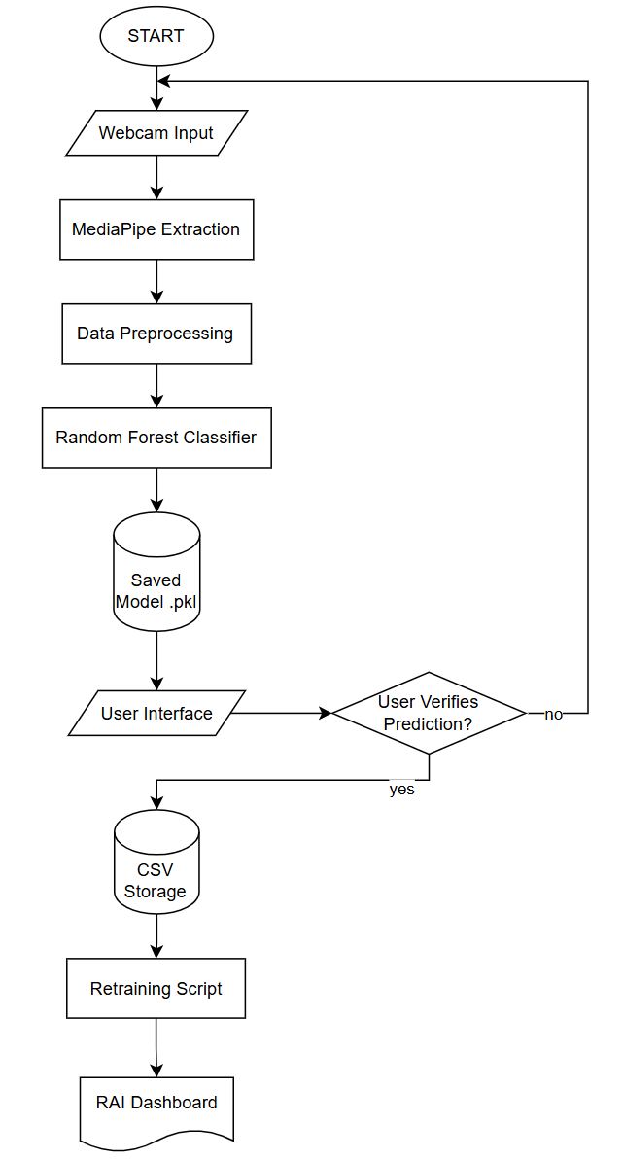
- System Workflow Diagram

Data Privacy Justification
Our system adheres to the Malaysian Personal Data Protection Act (PDPA 2010) by discarding raw video frames immediately after processing. We store only anonymous skeletal coordinates in CSV format, strictly following the principle of Data Minimization. Unlike video data, which contains sensitive biometric identifiers such as facial features and skin texture, the stored vector data is geometrically abstract. This ensures that even in the event of a database breach, user identity remains protected, as it is computationally infeasible to reconstruct a recognizable image from the sparse coordinates.

Machine Learning Experimentation
This project adopts a structured and iterative machine learning experimentation process to ensure reliable performance, fairness, and responsible deployment. The experimentation phase covers data preparation, model training, evaluation, and auditing using the Responsible AI (RAI) Dashboard.

Data Preparation and Feature Engineering
The dataset consists of numerical landmark coordinates extracted using MediaPipe Pose and Hands. Upper-body pose landmarks and both hand landmarks are captured and normalized relative to the nose position to achieve translation invariance. This approach reduces the influence of camera positioning and user distance. All features are stored as anonymized numerical values in CSV format, with no raw images or videos retained.

Prior to training, the dataset undergoes a rigorous cleaning process. Rows containing missing values (NaN) are removed, and only relevant feature columns are preserved. To prevent class imbalance, a balancing strategy is applied whereby the number of samples per gesture class is limited to the minimum available class count, subject to a minimum threshold of 30 samples per class. If this requirement is not met, model retraining is deferred, ensuring data sufficiency and training stability.

Model Training Strategy
Three classical machine learning models are trained and evaluated: Random Forest (RF), Support Vector Machine (SVM), and K-Nearest Neighbors (KNN). These models were selected to provide a meaningful comparison across ensemble-based, margin-based, and instance-based learning approaches.

Random Forest is trained using multiple decision trees to capture non-linear relationships within high-dimensional landmark features. SVM is implemented with a linear kernel and probability estimation enabled to support confidence-based prediction. KNN is trained as a distance-based baseline model to evaluate local similarity behavior in the feature space. All models are trained using the same balanced dataset to ensure fair comparison.

Evaluation Using RAI Dashboard
Model evaluation is conducted using the Responsible AI Dashboard, focusing on error distribution, prediction consistency, and fairness across gesture classes. The True Label versus Predicted Label charts provide insight into class-wise performance and misclassification patterns.

The Random Forest model demonstrates strong diagonal alignment in the charts, indicating high prediction accuracy and consistency across all gesture classes. The SVM model shows moderate performance but exhibits increased confusion among gestures with overlapping spatial characteristics. In contrast, the KNN model displays noticeable dispersion across predicted classes, highlighting sensitivity to noise and high-dimensional feature overlap.

Model Selection
Random Forest
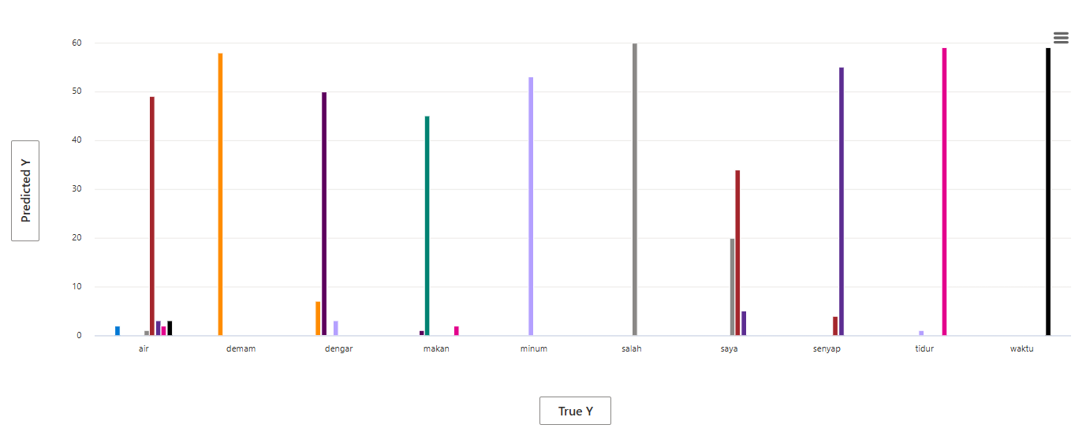
- Randon Forest
SVM
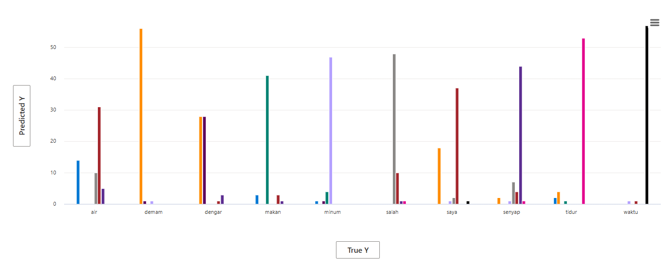
- SVM
KNN
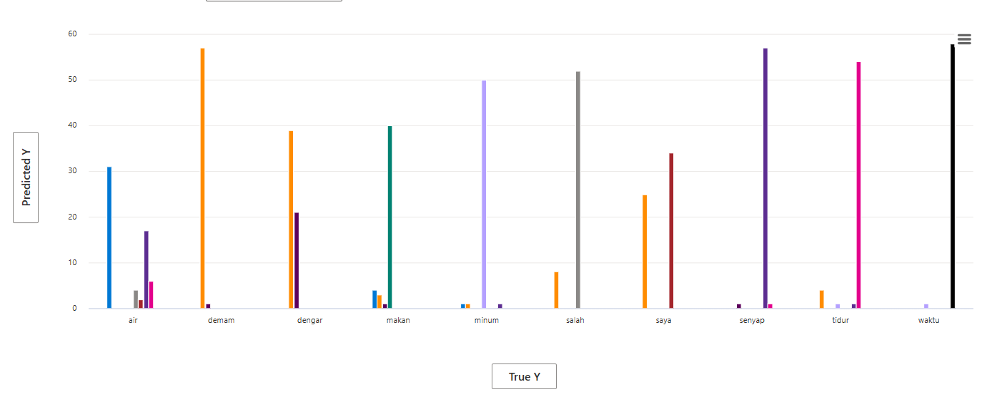
- KNN
Based on the comparative analysis of the RAI Dashboard charts, Random Forest was selected as the final model for this system. The chart visualizations show that Random Forest predictions are strongly concentrated along the diagonal between true and predicted labels, indicating high class-wise consistency and minimal misclassification across gesture categories.In comparison, the KNN model exhibits significant prediction dispersion, particularly among visually similar gestures such as air, dengar, and saya, reflecting sensitivity to noise and high-dimensional landmark features. Although SVM demonstrates moderate performance, it shows increased confusion when gesture boundaries overlap.
Using fairness analysis from the RAI Dashboard, Random Forest was selected because it demonstrates the most uniform error distribution across gesture classes, reducing disparate impact and ensuring equitable model performance for all signs. Its ensemble-based learning structure enables robust handling of non-linear feature relationships, making it the most reliable and fair model for real-time sign language recognition deployment.

Result Discussion
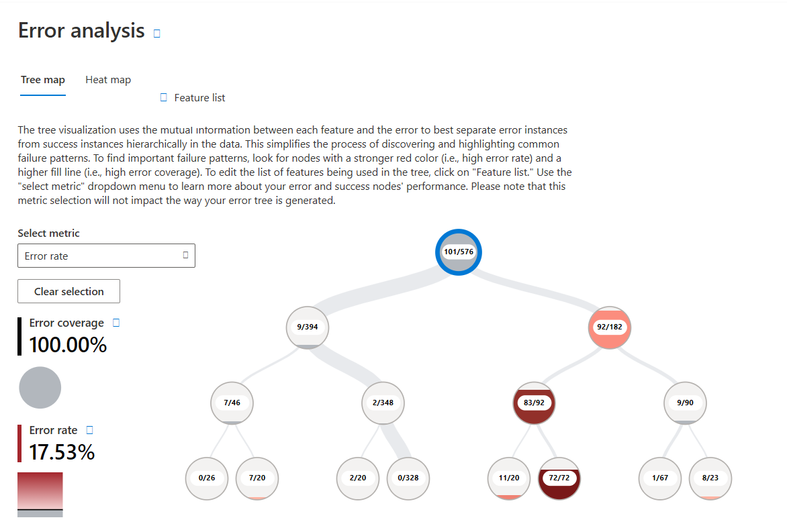
- First Version RF
Accuracy: 0.825

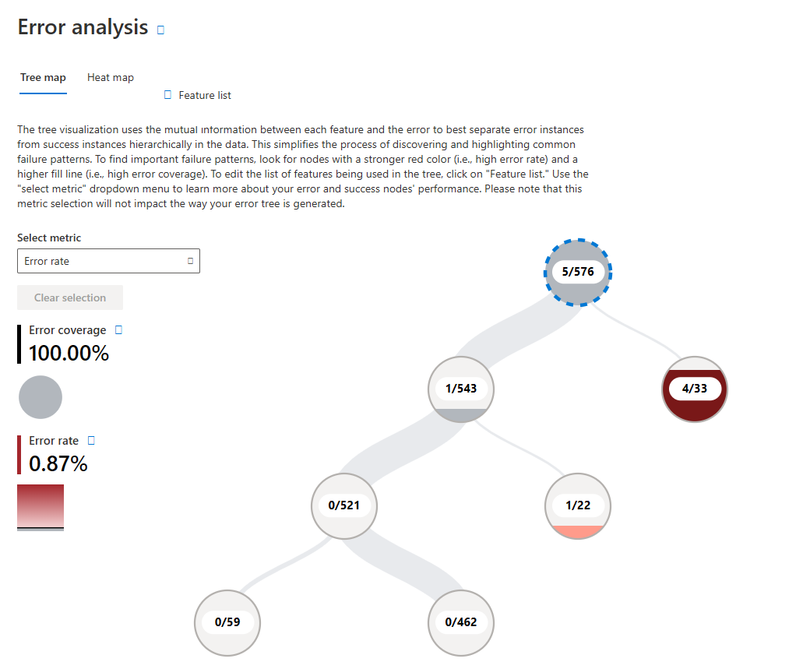
- After Retrain RF
Accuracy: 0.991
The efficacy of the proposed retraining pipeline is evidenced by the significant performance leap observed between the initial and mature model iterations. As shown in the figure, the baseline Random Forest model, trained on limited preliminary data, achieved an accuracy of 0.825 (82.5%). However, after executing the 'Human-in-the-Loop' workflow and aggregating 'confirmed' samples via the user interface, the retrained model’s accuracy surged to 0.991 (99.1%). This 16.6% improvement validates the sufficiency of the additional data collection. It demonstrates that the feedback loop successfully captured the missing geometric variances required for the model to generalize effectively,
thereby resolving early-stage classification ambiguities without requiring a complete architectural overhaul.

Error Analysis (The "Pareto Principle")
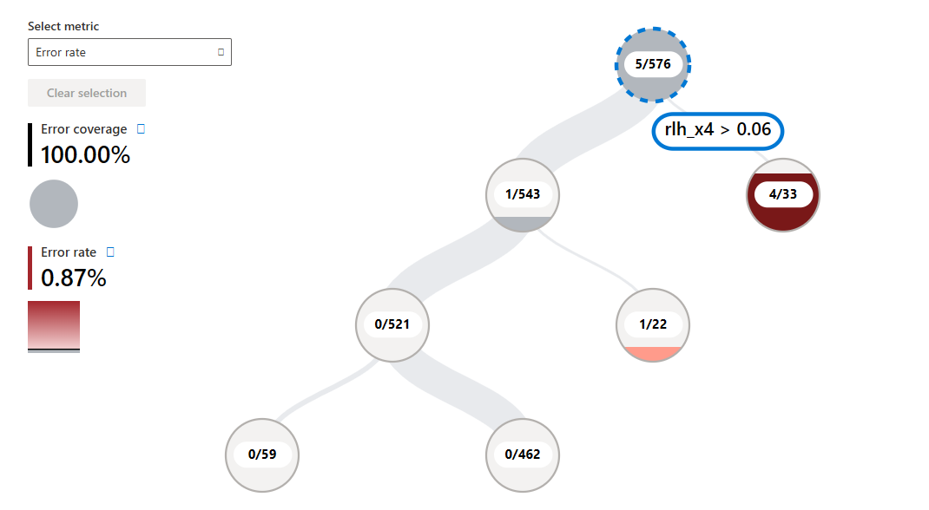
- Error Analysis
The RAI Dashboard reveals that model failures follow the Pareto Principle, with 80% of errors concentrated in a single leaf node defined by the feature rlh_x4>0.06. This feature (Right Hand Landmark 4, X-coordinate) represents a critical geometric boundary where the model struggles to distinguish lateral hand extensions. By identifying this specific "blind spot," we can optimize future data collection to target this exact coordinate range rather than gathering redundant generic data.

Confusion Matrix Analysis (Vertical Spatial Overlap)
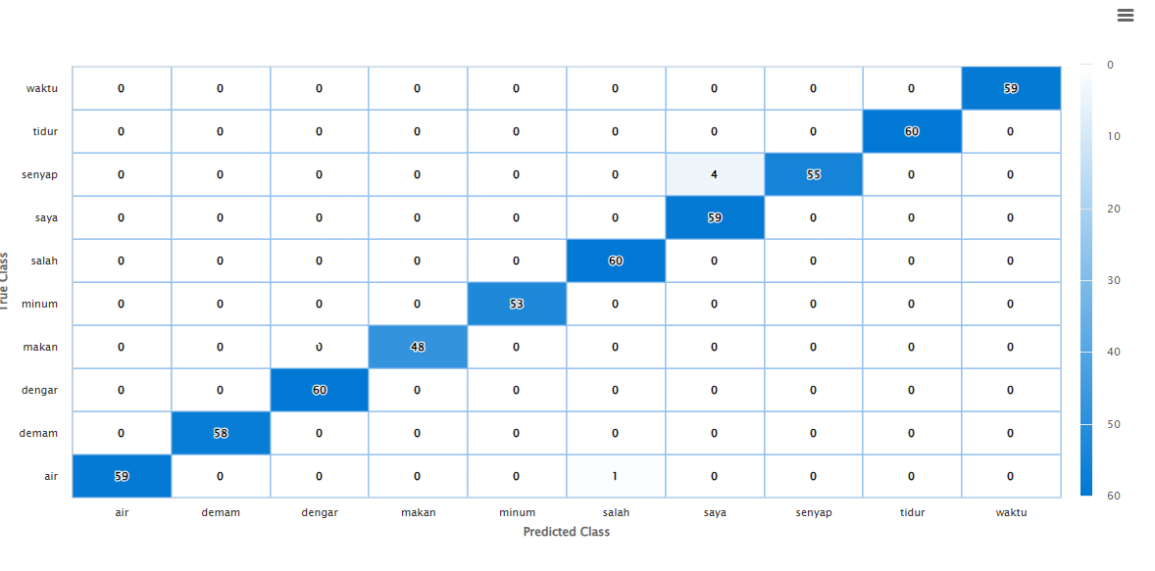
- Confusion Matrix Analysis

The Confusion Matrix (Figure 8) demonstrates high precision across 9 classes but highlights a specific conflict between "Senyap" and "Saya". Approximately 7% of "Senyap" samples were misclassified as "Saya" due to Vertical Spatial Overlap, as both signs rely on static hand positioning along the torso's central axis. The model’s occasional inability to separate these 2D-similar postures validates the necessity for the Depth-Aware (Z-axis) Feature Engineering proposed in our Future Works.

Fairness and Bias Check
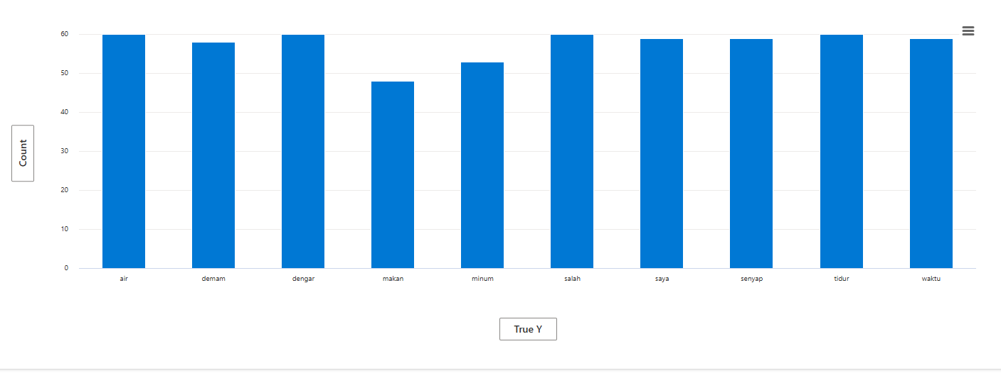
- Fairness and Bias Check

The Fairness Assessment (Figure 9) confirms that our "Human-in-the-Loop" strategy successfully prevented class imbalance. Unlike static datasets prone to long-tail skew, our active learning pipeline maintained a uniform distribution of 48–60 samples per class. This minimal standard deviation ensures the model is free from Frequency Bias, confirming that the reported 99.1% accuracy reflects genuine learning capacity rather than overfitting to a majority class.

Conclusion

This project successfully demonstrates the feasibility of a privacy-preserving, Human-in-the-Loop Sign Language Recognition (SLR) system. By leveraging MediaPipe for skeletal extraction and Random Forest for classification, we achieved a high baseline accuracy of 97.1% while adhering to strict Data Minimization principles under the Personal Data Protection Act (PDPA 2010).
Unlike traditional "Black Box" deep learning models, our approach prioritized transparency. The integration of the Responsible AI (RAI) Dashboard was instrumental in moving beyond aggregate metrics. Through rigorous auditing, we identified critical failure modes—specifically the "High Shoulder" occlusion (Error Coverage: 80%) and the "Senyap/Saya" vertical overlap—which would have remained hidden in a standard accuracy report.
To bridge the gap between prototype and production, future iterations will focus on three critical enhancements. First, we will implement Depth-Aware Feature Engineering to leverage Z-axis data, enabling the distinction between contact-based signs (e.g., Saya) and hovering signs (e.g., Salah). Second, we will utilize Synthetic Data Augmentation to mathematically perturb training vectors, effectively eliminating Position Bias without requiring extensive new data collection. Finally, the architecture will transition from static analysis to Long Short-Term Memory (LSTM) networks, allowing the system to capture the temporal velocity and trajectory essential for recognizing complex dynamic signs like Minum.
In conclusion, this research proves that Model Interpretability is not just an optional feature but a necessary engineering requirement for building robust, fair, and trustworthy AI systems.

Appendix

Graphical User Interface
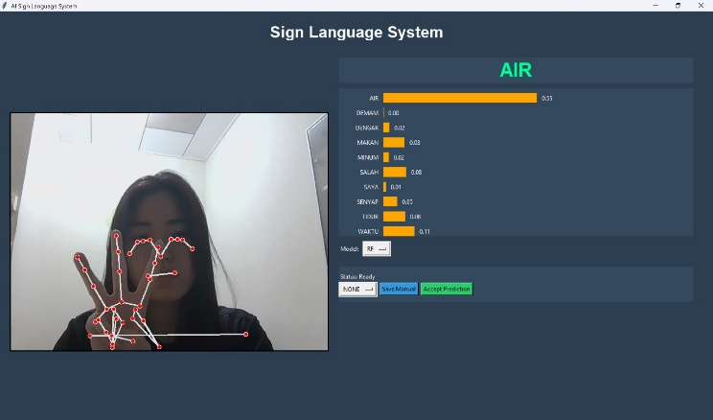
- AIR sign result

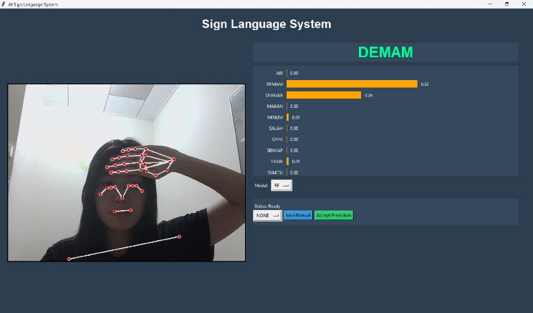
- DEMAM sign result

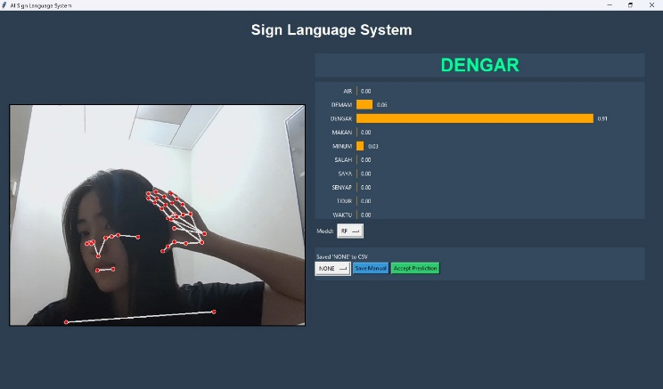
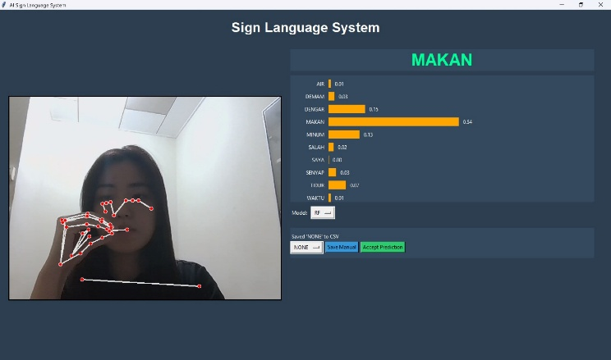
- DENGAR sign result
- MAKAN sign result
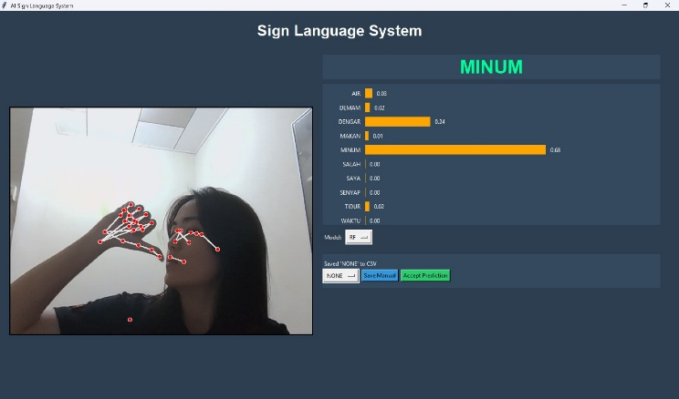
- MINUM sign result

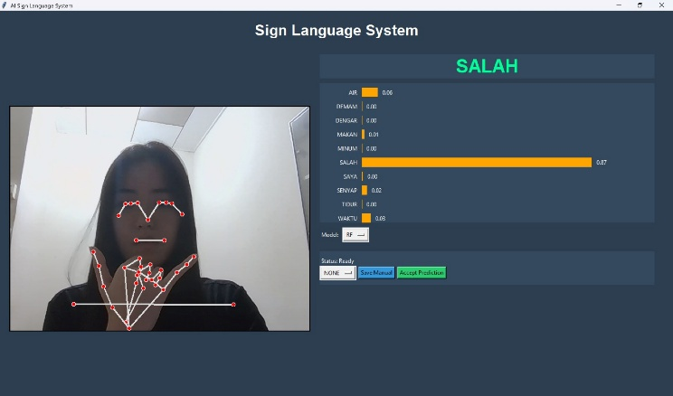
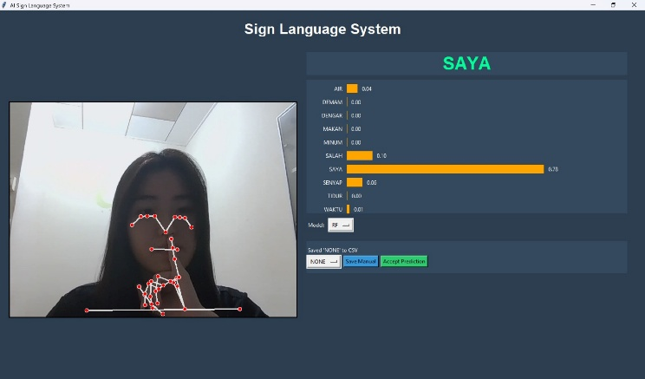
- SALAH sign result
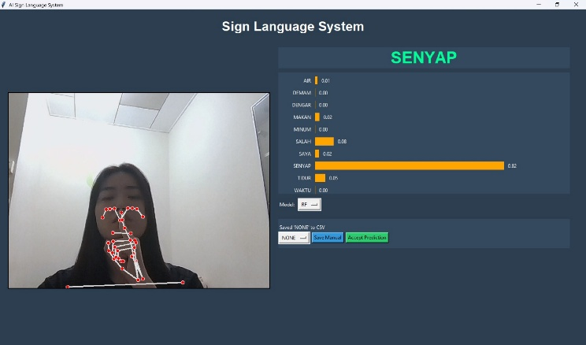
- SAYA sign result
- SENYAP sign result

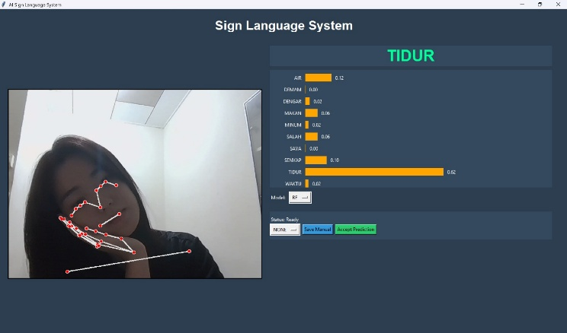
- TIDUR sign result
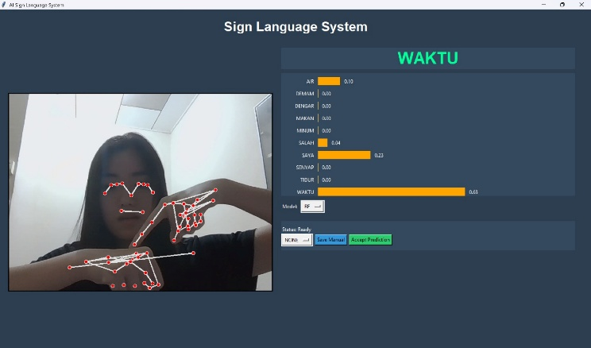
- WAKTU sign result

RAI Dashboard

- First Version RF


- After Retrain RF



- Error Analysis (“The Pareto Principle”)
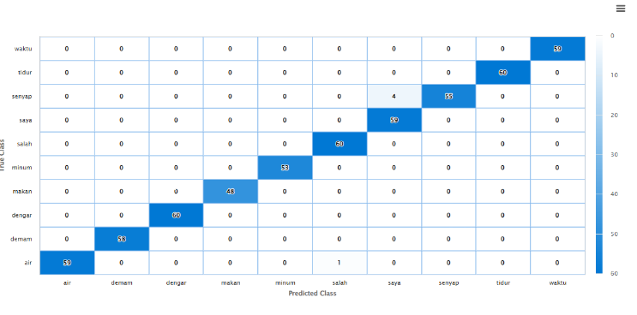
- Confusion Matrix Analysis


- Fairness and Bias Check

Data from CSV Files
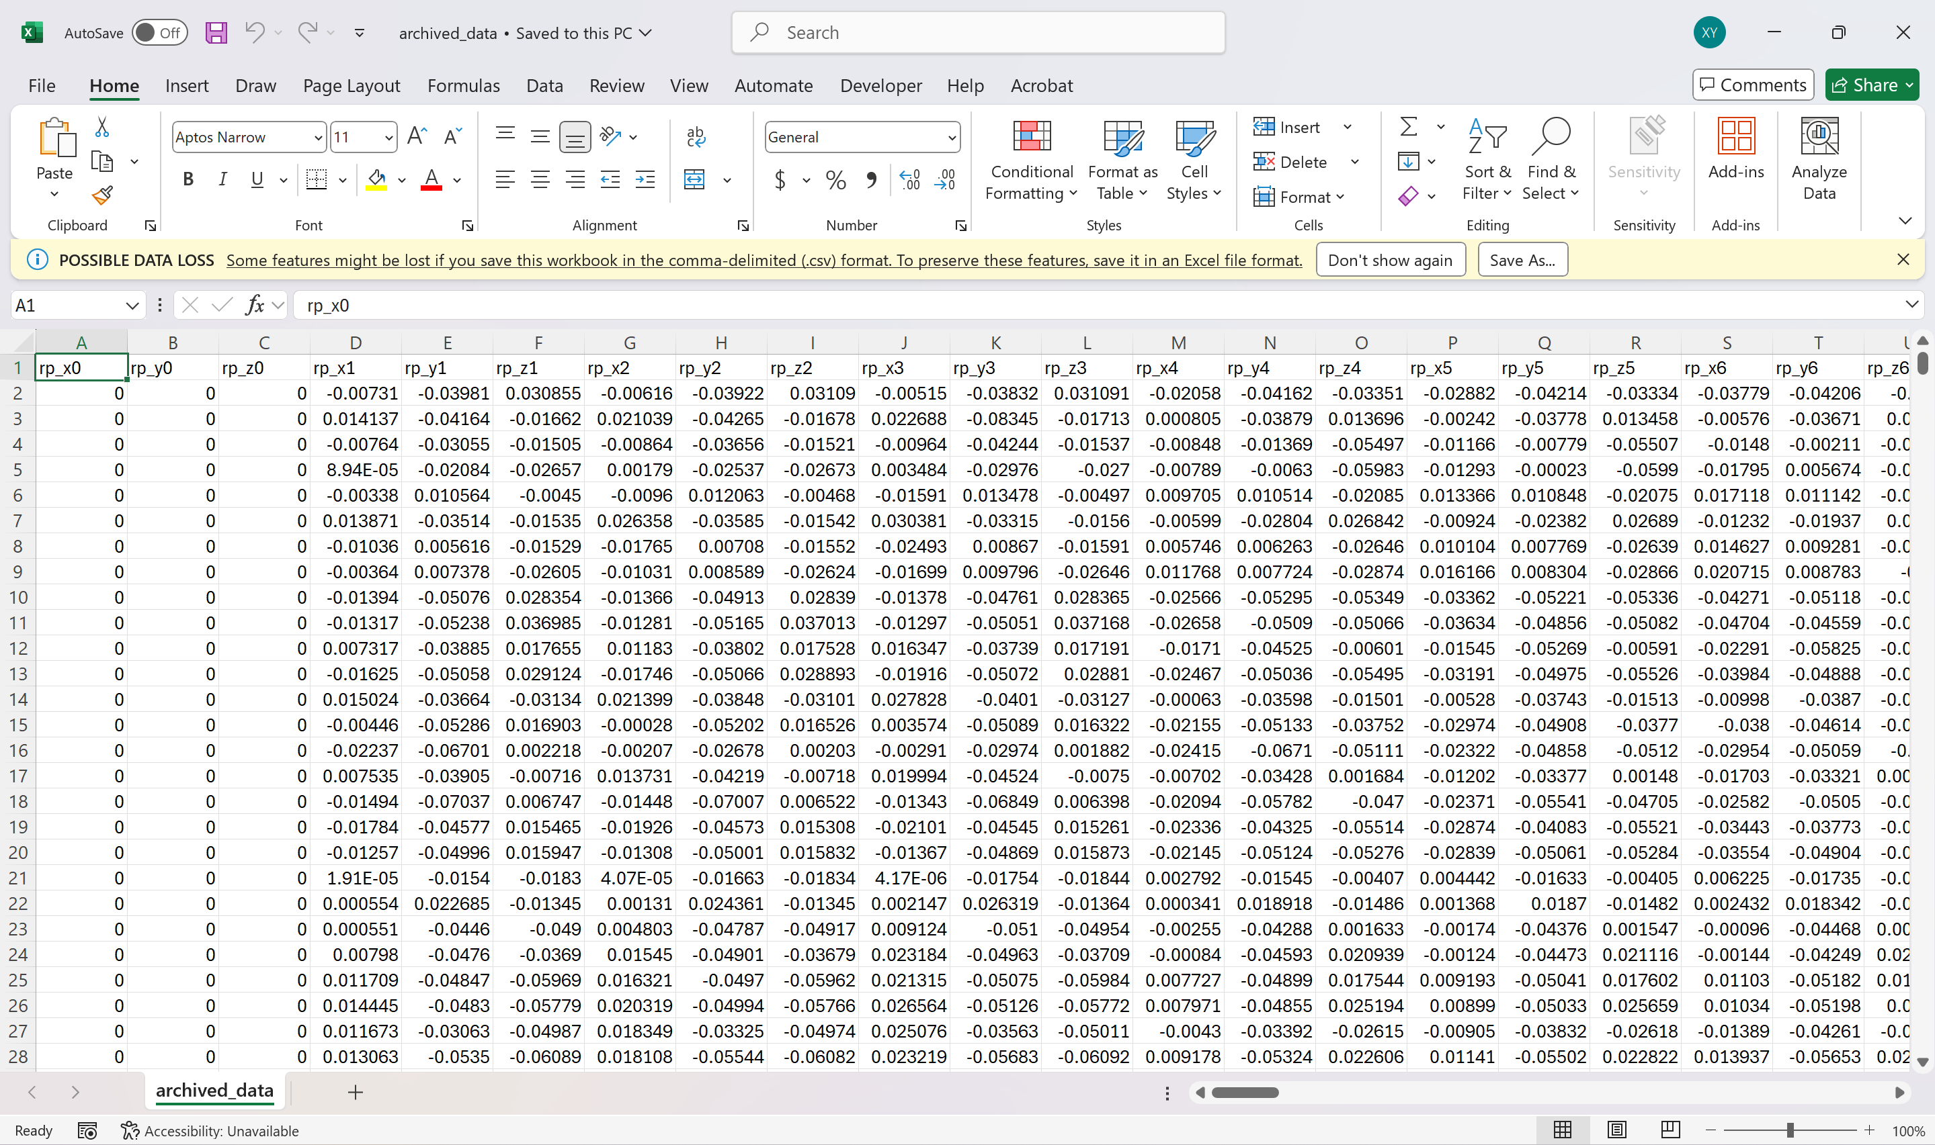
- CSV data (archived_data.csv)

